Annotated

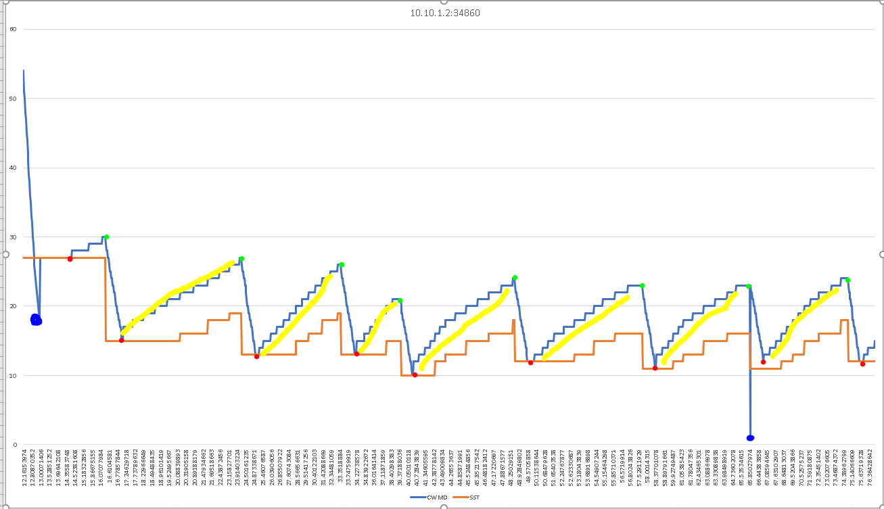

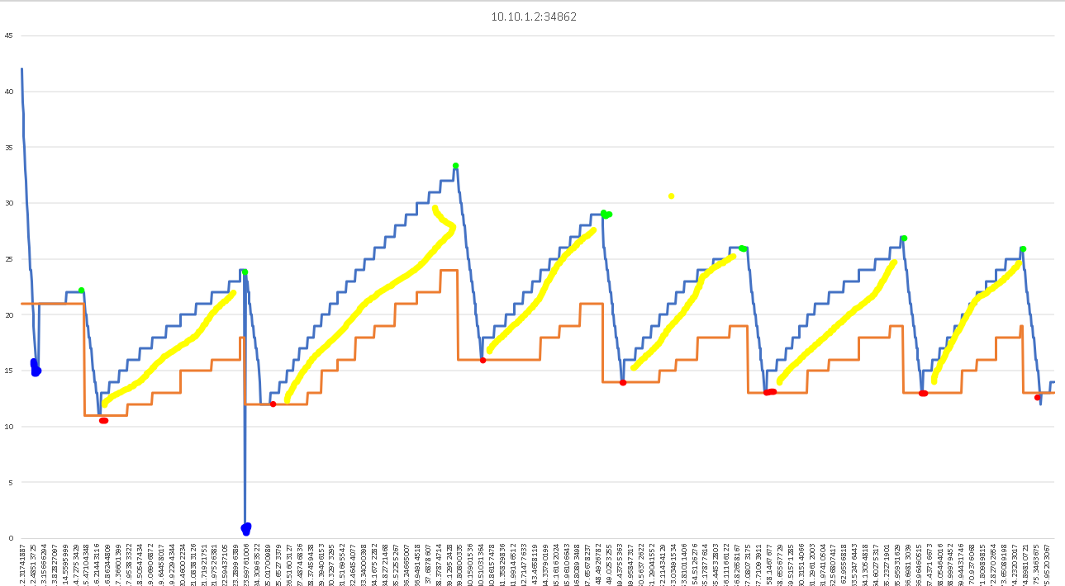

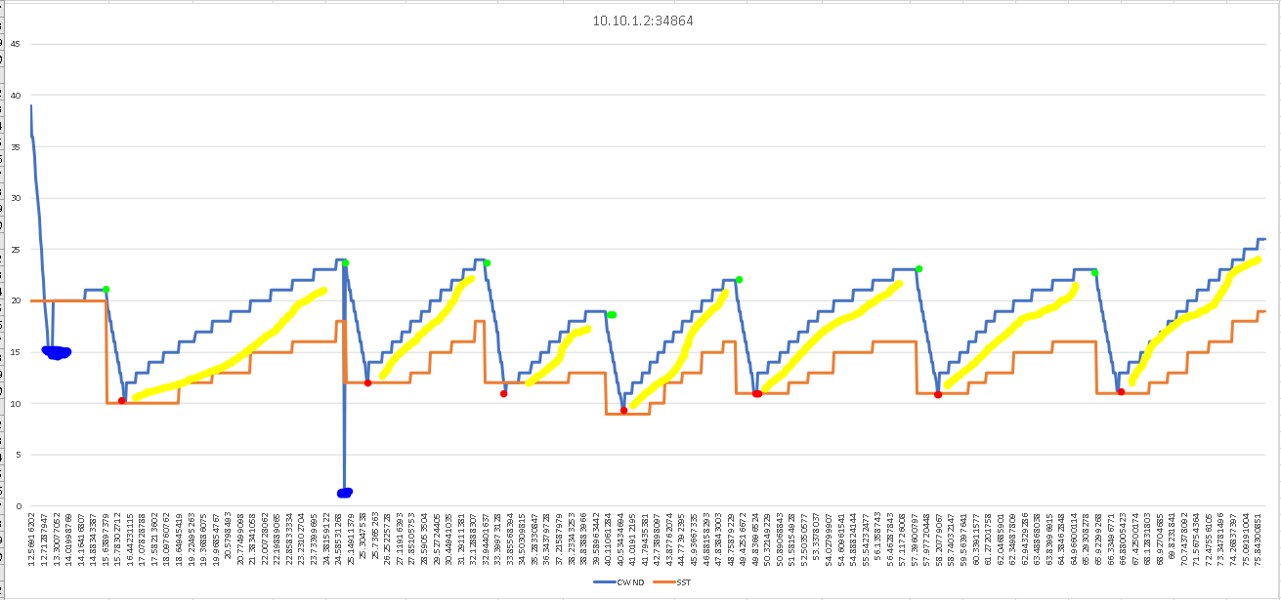

Lime Green is for triple dup acks received

Blue dots are for timeouts (not the best color choice for blue lines, I know)

Red is for when slow start begins to happen

The yellow line below the blue is for the sections of congestion avoidance

Using plot/ experiment date explain behavior of TCP is different in slow start and congestion avoidance phases

The difference is a visible one I believe. As you can see in the graph there is a part of the blue line that is taller than it is wide. This denotes the slow start as there are more packets being sent in that time than normal which means it is restarting. The congestion avoidance is the consistent incline of stair-like incline of the SST and CWND.

Explain congestion window and slow start threshold when triple dup acks are received

The congestion window (CWND) is halved and the slow start threshold(SST) appears to also be halved but also adds on an extra 3 . So if it was 18 it would go to 12 as seen in the last graph on the first instance of the packets being recieved

Summary:

In this lab I became more familiar with the tools that we learned previously in other labs. This lab was not too difficult but it made me do a quick crash course in excel to be able to make the graphs again. This was a bit time consuming but it was fine in the end. This greatly improved my excel skills again as I forgot how to manipulate graphs in excel

This lab also was able to give me a visual representation of what was happening as it is easier to look at and learn from in the graph form than it is of the data sheet. It was interesting when the internet went down in the lab as I was trying to complete the lab. It also taught me a bit of patience